DFS Plan – Adam Riley

The first level layout is as follows:

* 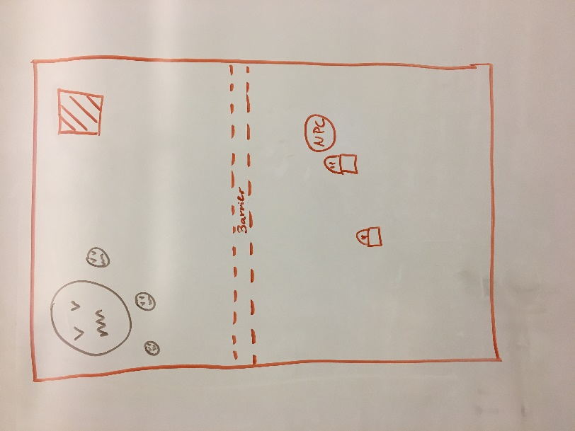Player starts at the bottom of the map.
  + Map is incursion style
* There is a barrier preventing the player from leaving bottom side.
* 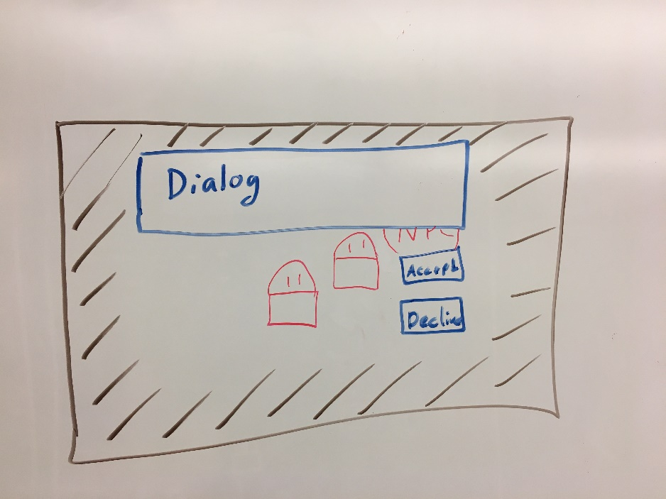The NPC is there ready to talk too.
  + NPC gives quest to kill enemies above barrier
* When interacting the player’s input is consumed by the UI system.
* Can Accept or decline.
  + First pass, decline just exits the Dialog without any consequences.
  + Second pass, there are consequences for declining quests.
* Camera is centered on player
* 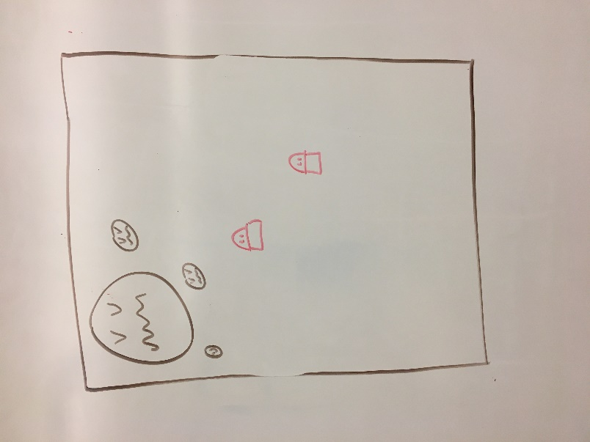Once, quest is accepted, you can pass through invisible barrier
* 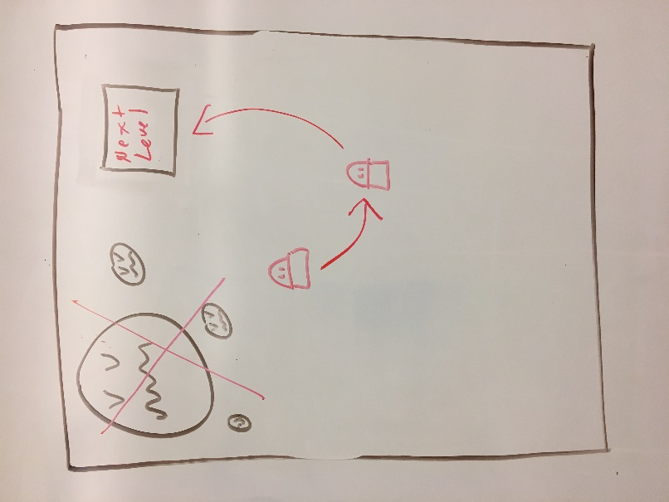Once, the quest is complete, Return to the giver to finish it. This will open a door to the next level.
* Once level one is done, other levels can be made but not required. Only if time allows.

Entity Component System

The rules that I would like to follow in the code I’m going to use this in are:

* Components only hold data, do no logic
* Systems only preform logic, have no data

This is to explore how easy it is to begin and add to games using this structure.

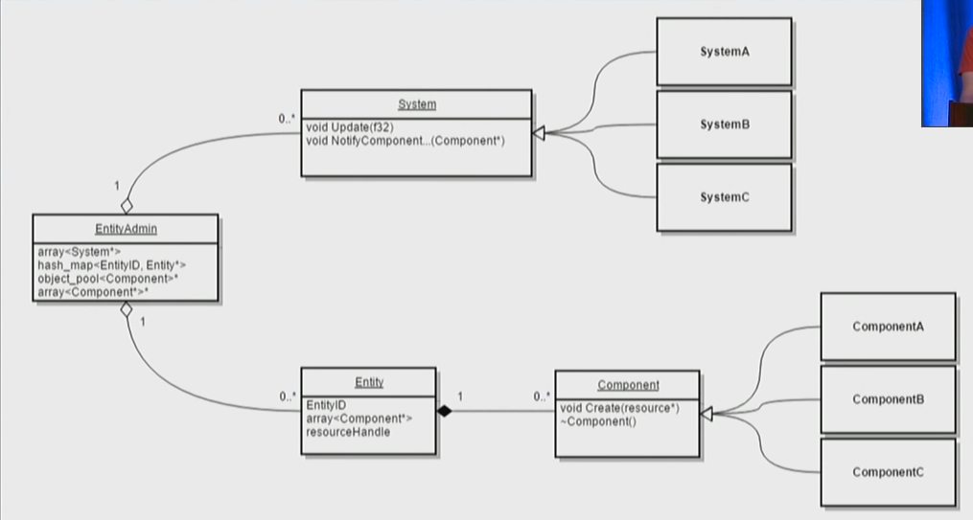References: https://www.youtube.com/watch?v=W3aieHjyNvw&feature=emb_logo

|  |  |  |
| --- | --- | --- |
|  |  | **Schedule** |
| **Week** | **DATE** | **DUE** |
| 1 | Jan 17 | Project Planning |
| 2 | Jan 21,24 | Project planning and Architecture |
| 3 | Jan 28,31 | Get Map setup and player moving – 4 hours  Get NPC made and interact – 4 hours |
| 4 | Feb 4,7 | Get UI and interactions – 4 hours   * Including starting the quest   Rendering and animation – 4 hours |
| 5 | Feb 11,14 | *** Out of town *** DICE Conference *** |
| 6 | Feb 18,21 | Get Enemies to spawn and barrier to drop – 4 hours  Combat –   * Player combat – 4 hours * Enemy combat – 2 hours * Polish and getting it to feel right – 2 hours |
| 7 | Feb 25,28 | Quest Finish   * Get Quest to attach to player – 1 hour * Allow update to Quest – 3 hours * Finish Quest and trigger exit to level – 4 hours |
| 8 | Mar 3,6 | **Midterm Presentation – Due 3/10** |
| **9** | **Mar 10,13** | **Midterm Presentations** |
| 10 | Mar 17,20 | *** Out of Town *** GDC *** (Spring Break) |
| 11 | Mar 24,27 | Multiple Levels – 2 hours   * Create multiple levels – 2-6 hours |
| 12 | Mar 31, Apr 3 | Quest fail / decline consequences – stretch goal   * Time depends of the changes |
| 13 | Apr 7,10 | Polish – 8 hours |
| 14 | Apr 14,17 | Presentation Prep / Ludum Dare Weekend |
| 15 | Apr 21,24 | Final Project Submissions and Presentations – Due  Presentation Prep |
| 16 | Apr 28 May 1 | **Final Presentations, Part 1** |
| **17** | **5/5** | Reading Day |
| **17** | **Wednesday**  **5/6** | **Final Presentation - 11 am** |